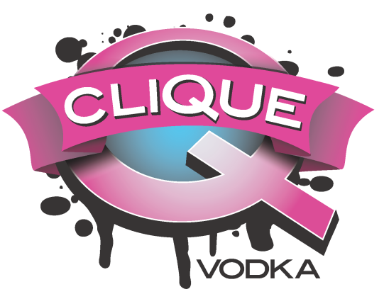
Custom Recipes
Pittsburgh Today Live

Black & Gold
1 ¼ oz Clique Vodka
½ oz Chai tea syrup*
4 oz lemonade
Pour Clique Vodka into glass over ice and add lemonade. Slowly add chai syrup so it collects at the bottom of the glass, creating a layered effect.

One Marvelous Mimosa
1 oz Clique Vodka
1 ½ oz Freshly squeezed orange juice
3 ½ oz Sparkling wine
Chill the Clique Vodka in a cocktail tin with ice and strain into a flute glass. Then add orange juice and slowly pour in the sparkling wine while holding the glass at an angle so it doesn’t overflow.

Spiced Cosmo
2 oz Clique Vodka
¼ oz Triple Sec
¼ oz Fresh lime juice
¼ oz Cranberry juice
¼ oz Chai tea syrup*
Shake all ingredients over ice in a cocktail shaker, and strain into cocktail glass. Garnish by removing the rind from an orange slice and twisting it into a spiral over top of the cocktail so that the spray of oil fall into the glass. Then take the rind and rub it around the outer rim and place on the lip.

Chai High
1 ¼ Clique vodka
4 oz Cranberry juice
½ oz Chai tea syrup*
Pour all ingredients over ice and stir. Garnish with a lime slice.

Hard Chai Cider
1 ¼ oz Clique Vodka
½ oz Chai tea syrup*
3 ¼ oz Apple cider
Grated cinnamon
Heat apple cider in a mug for about 45 seconds. Then add in the chai syrup and Clique Vodka. Grate a cinnamon stick over top for garnish and drop it in as a functional stirring stick.

*Chai Tea Syrup
Chai tea bags
Water
Sugar
Bring 2 parts water to a simmer and turn off heat. Add 3x the amount of teabags you would normally use to brew tea. Let steep for about 10 minutes and remove teabags. Then stir in 1 part sugar until completely dissolved. Let cool, and syrup can be stored in the refrigerator for up to 2 weeks, longer if you add 1/3 part Clique Vodka as a preservative.

